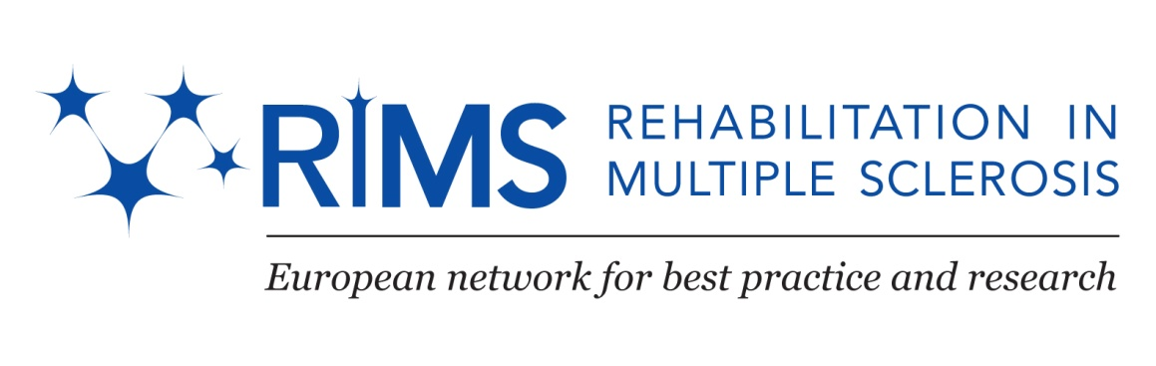

Special Interest Group (SIG) on Occupation & Mobility

in-between co-meeting 2012, Milan, Italy

The use of clinical approaches including advanced technology systems for maximizing the effect of rehabilitation on mobility and function.

Local Organizers: Davide Cattaneo, Johanna Jonsdottir

Chair and Co-Chair SIG Occupation: Daphne Kos (B) and Tarja Huilla (FI)

Chair and Co-Chair SIG Mobility: Anders Romberg (FI) and Paul van Asch (B)

RIMS Chair: Peter Feys (B)

THURSDAY November 8th

Meeting venue: Don Gnocchi Foundation, Via Capecelatro 66, Milan

Accommodation: Hotel Montebianco - www.hotelmontebianco.com/
Afternoon/Evening Flight Arrival to Malpensa (50’ train (Malpensa Express) or Linate (Bus or taxi to Milan) or Orio al Serio, Bergamo (Bus to Milan, Central Station) or Train arrival to Central Station (Metro).

From 19:30 – Welcome Drink and Pizza (Hotel Montebianco – to be confirmed)

Program

FRIDAY NOVEMBER 9th

Meeting Venue: Don Gnocchi Foundation, Milan

08:15 – 08:30 Registration

08:30 - 08:50 Welcome to Milan
Introduction to the SIG theme & participants

SCIENTIFIC SESSION I: UPPER LIMB FUNCTION

(Joint session: SIG Mobility and SIG Occupation)

Chairs: Claudio Solaro and Tarja Huilla
08:50 - 09:15 New opportunities for the upper limb rehabilitation in MS: from theoretical concepts to clinical practice
Núria Fillo & Carme Santoyo (ES)

09:15 – 09:40 Instrumented assessment of Upper limb disorders in MS
Ilaria Carpinella (I)

09:40 – 10:05 Robot-assisted training for the upper limb in Multiple Sclerosis: I-TRAVLE concept and results of a RCT
Peter Feys (B) Tori Smedal, K Jones, Norman Britt, Kurt Luyckx, Alon Kalron

10:05 – 10:30 Effects of Fampyra (Fampiridin) on ADL performance and upper limb function.
Inger Grethe Løyning (N)

10:30 - 10:55 COFFEE BREAK

Chairs: Daphne Kos and Davide Cattaneo

10:55 - 11:20 Use of robot therapy for Upper limb
Claudio Solaro (I)

11:20 – 11:45 Multicenter study on arm function in MS
Ilse Lamers (B) and Rita Bertoni (I)

Practical Session

11:45 – 12:40 Robotic treatment for upper limb, Leonardo Biofeedback device, Mc Fes Device.
Ilaria Carpinella (I), Alessandro Crippa (I), Riccardo Parelli (I).

12:40 – 13:40 LUNCH

SESSION I (SIG Occupation):

Clinical and instrumental assessment & rehabilitation of activity & participation

13:40 – 14:10 PIDA a power-mobility indoor driving assessment for PwMS
Pascal Vanderbeeten (B)

14:10 – 14:40 Neuromuscular taping: influence on spasticity & oedema
Tarja Huilla & Elina Kuohuva (FI)

14:40 – 15:10 Integration upper limb in daily life: case report
Jelka Jansa & Zorana Sicherl (SL)

15:10 – 15:40 COFFEE BREAK

15:40 –16:10 The use of AMPS in the assessment of neurological patients
Ingela Johnson (S)

16:10 –16:30 In-between report of AMPS study
Jelka Jansa (SL) & Daphne Kos (B)

16:30 –17:30 Discussion and closing day 1
.

20h30 DINNER (Location to be announced)

SATURDAY NOVEMBER 10th

Meeting Venue: Don Gnocchi Foundation, Milan

SESSION II (SIG Occupation)

09:00 - 09:30 New technologies in assistive devices: review
Pascal Vanderbeeten (B)

09:30 - 10:00 Occupation: concept and assessment
Daphne Kos (B)

10:00 - 10:30 Take home messages / Future plans

10:30 - 11:00 COFFEE BREAK

11:00 - 13.30 Meeting of AMPS study group (for participating centers)

End of the meeting

