Report in-between meeting
RIMS SIG Patient Autonomy/ Psychology and Neuropsychology
28th to 29th of November 2019 in Hamburg
Pictures

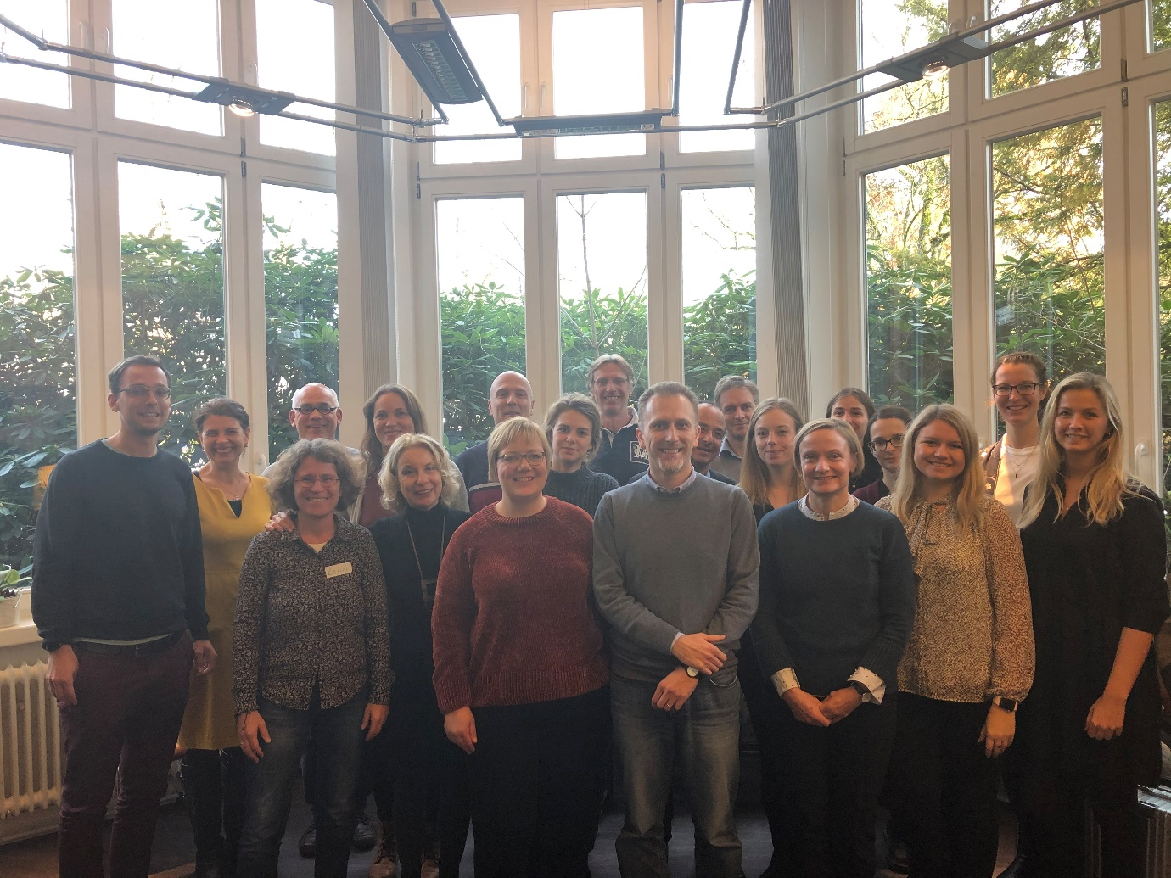
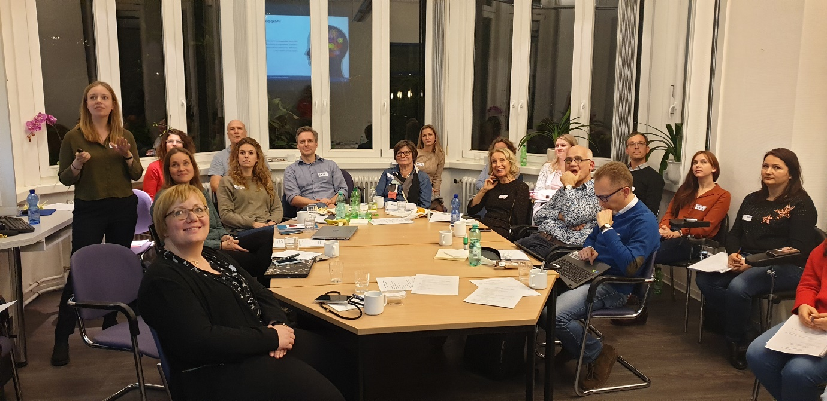
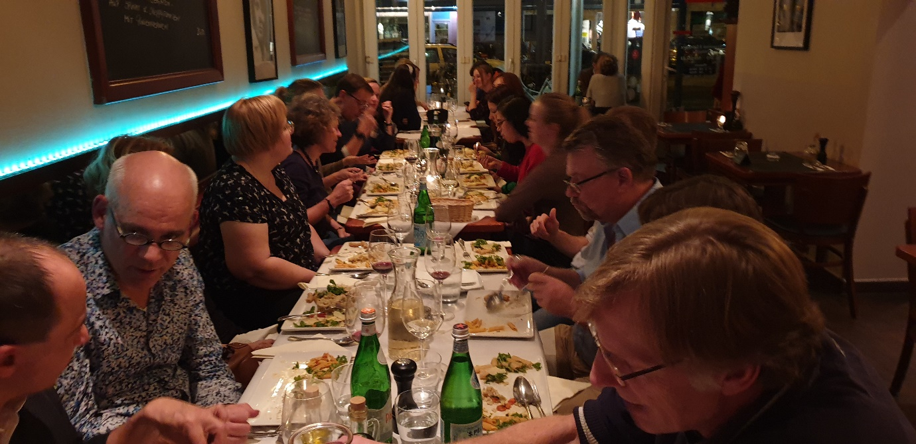
Participants
Valeria Grosu Romania
Thomas Lehnert Germany
Elena Frick Germany
Lisa Wenzel Germany
Anja Holz Germany
Wim van de Vis Netherlands
Lasse Skovgaand Denmark
Nicole Krause Germany
Anna Barabasch Germany
Sofie Bergien Denmark
Karin Riemann-Lorenz Germany
Emma Nicholas UK
Alessandra Solari Italy
Michael Nissen Denmark
Marie Lynning Denmark
Tent, Christina Romania
Astrid Kanoe Denmark
Rebecca Morrison Germany
Julia Peper Germany
Susan Seddiq-Zai Germany
Anne Rahn Germany
Jana Pöttgen Germany
Christoph Heesen Germany
Jannie Engelbrecht Denmark
Richard Nicholas UK
Andrea Giordano Italy

Summary of the meeting
In total, 26 people from six european countries particpated in the shared SIG psychology and patient autonomy in-between meeting in Hamburg, Germany. One of the particpants was a patient representative.
One of the main aims of the meeting was to exchange shared research interests and to develop “synergy effects” between the participating centres. The program included presentations with theoretical background and practical research approaches/projects including the experiences to implement the projects into clinical work. We experienced a strong overlap of research interests and started to discuss and develop possible shared work. Because of the specific interest and knowledge of the centres in online research (including both cross-sectional data collection and online treatment with eHealth programs), new and further collaborative projects seem to be possible and not too difficult to establish.
The in between meeting gave many opportunities to discuss practice, exchange ideas, be inspired and make new friends and colleagues in the RIMS network. The network dinner at Thursday night was a perfect platform to discuss personal research interests in a friendly interaction.

Future plans and meetings
2020 activities include:
A more interactive exchange is planned to bring both research activities in Psychology and Lifestyle together. The Hamburg Group and the Danish Group will exchange knowledge and experiences on Lifestyle Management projects, the chances and difficulties of self-monitoring with online tools and the development of online tools to increase MS-specific food health literacy. The possibilities of collaboration on those topics will be explored in the first months of 2020.
Further, the Danish group showed also interest to particpate in the planned multinational survey on the motherhood choice topic and to participate on research activities in the field of severe MS.
A joined and a separate meeting (SIG Psychology/Neuropsychology and SIG Patient Autonomy) during the RIMS annual Conference in Belgium in June 2020 are planned. Another In-between meeting held in autumn 2020 at a RIMS member center (e.g. Kobenhavn) is planned.

