Report SIG Occupation
When and Where: 22. November – 24. November 2018, Haslev, Denmark
Topic of the meeting: 2+2=5 – The synergies of multidisciplinary rehabilitation

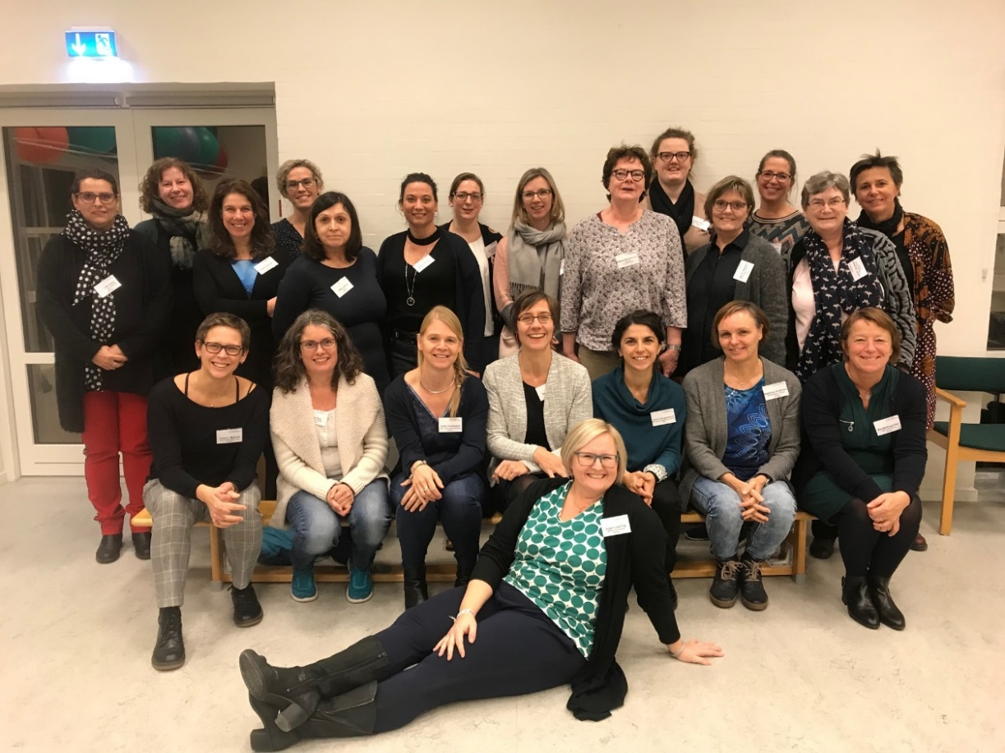

All participants present in group picture, except Sara Rasselnberg.

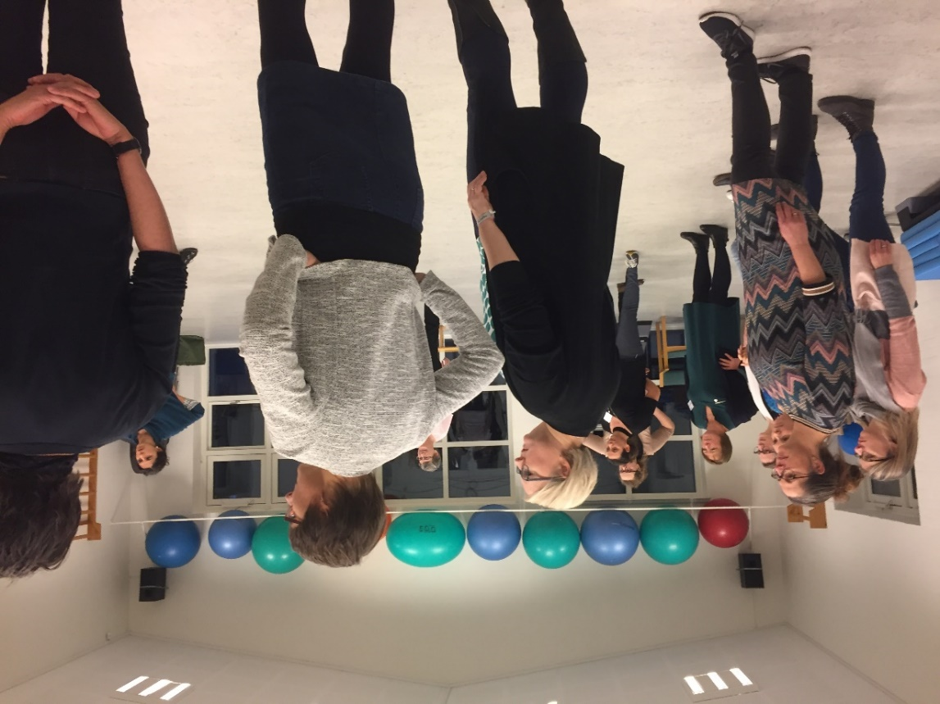
List of Participants:
Lena Lundman Myrlund, Sweden
Valeria Bergamaschi, Italy
Jelka Jansa, Slovenia
Isaline Eijssen, Netherlands
Heidi Marie Visby Jacobsen, Denmark
Hellemai Andersen, Denmark
Sara Rasselnberg, Denmark
Jytte Rose Jakobsen, Denmark
Christina Mortensen, Denmark
Inge Gjerrild Soegaard, Denmark
Charlotte Seistrup Krogh, Denmark
Anne Dyreborg, Denmark
Stine Thorup Nielsen, Denmark
Lene Munch Kallmayer, Denmark,
Marijke Duportail, Belgium
Joke Raats, Belgium
An Cleuren, Belgium
Sofie Ferdinand, Belgium
Jeanette Richwood, Norway
Hilde Ryg, Norway
Daphne Kos, Belgium
Heleen Beckerman, Netherlands
Inger Grethe Løyning, Norway

Summary of the meeting
If two words could summarize the meeting it would be “Synergy effects”. The program included both theoretical lectures and practical workshops, we experienced that theory and practice are better together. Trying to use the TIDieR checklist in small groups was fun and frustrating, but gave inspiration to bring home to our clinical practice. We got hot news on the results from the Danish RCT on effects of multidispiclinary rehabilitation. Presentations of vocational rehabilitation (VR) in two European countries taught us about synergy effects of teamwork in VR. We participated in an inspirational neurological music therapy session and learned about the synergy effects of music to our brain. Presentations on recilience, clinical pathways, synergy effects of multidisciplinary rehabiltiation, the role of the occupational therapist in multidisciplinary team and the use of Armeo Spring for Arm training completed the scientific program. In addtion, we were well taken care of by the local organizers, in beautiful environments both at the venue and in the cozy town of Ringsted. The two-day meeting gave good opportunities to discuss practice, exchange ideas, be inspired and make new friends and colleagues in the RIMS network.

Future plans and meetings
2019 activities include:
3-hour meeting during the RIMS annual Conference in Ljubliana, Slovenia June 20th.
In-between meeting held in the autumn at a RIMS member center (not confirmed location yet)

